**Use TEXT Module in adobe forms**

1. Go to tcode SMARTFORMS. Create a text module ZRT_DEMO_TEXTS and give the following text in it

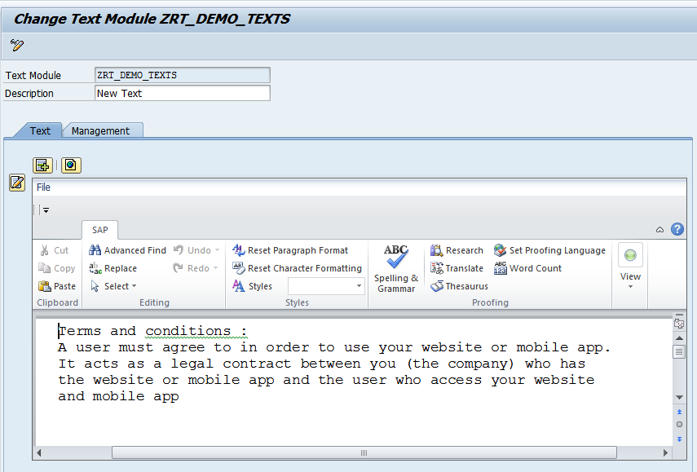

1. Go to Tcode SFP .Create an interface and then create a form(For details ,please refer the previous demos)

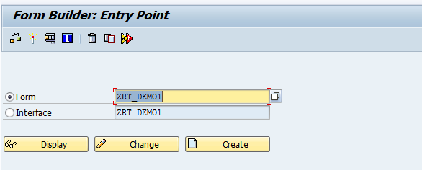

1. Open the Form in SFP. Right click on folder and create text as shown.

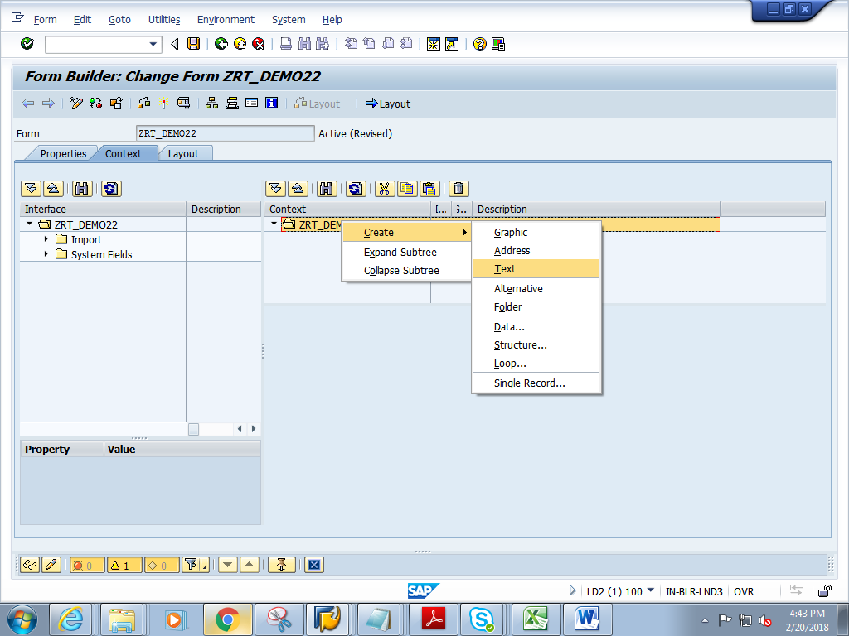

1. Rename the text to LV_TEXT and give text name as **ZRT_DEMO_TEXTS** and press enter  
   (Note ZRT_DEMO_TEXTS is created in tcode smart forms in step 1 of this demo)

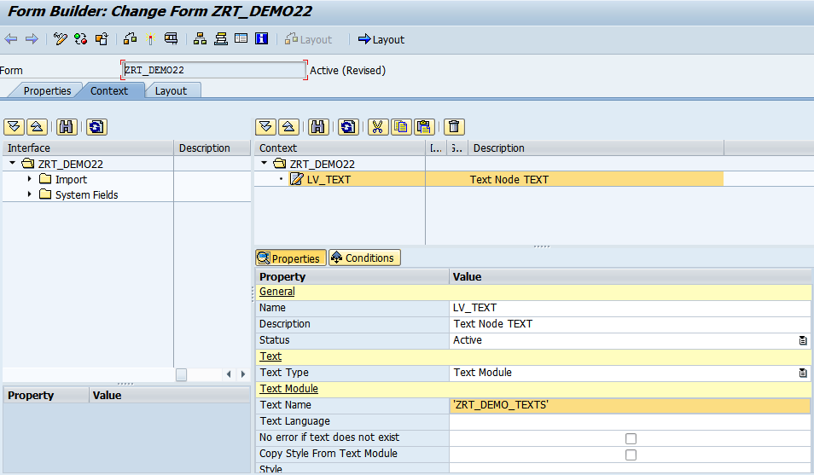

1. Save and click on Layout
2. In the Layout, drag and drop Text from Object Library to Design View. Resize the Text box and make it big enough.

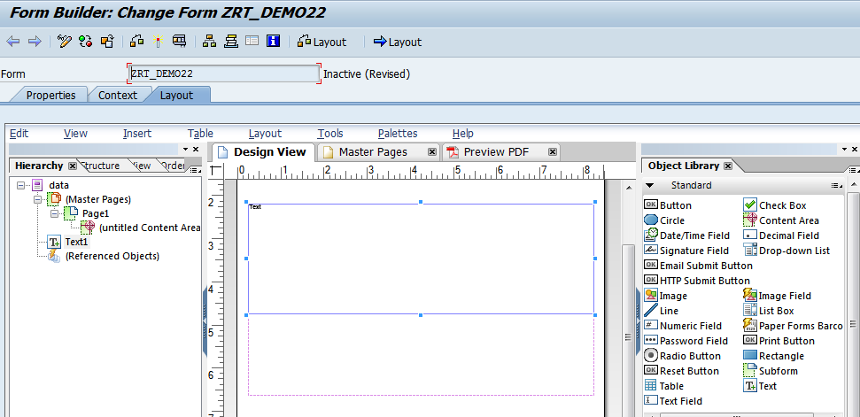

1. Right click on the word **Text** in the Text box and choose Floating field option

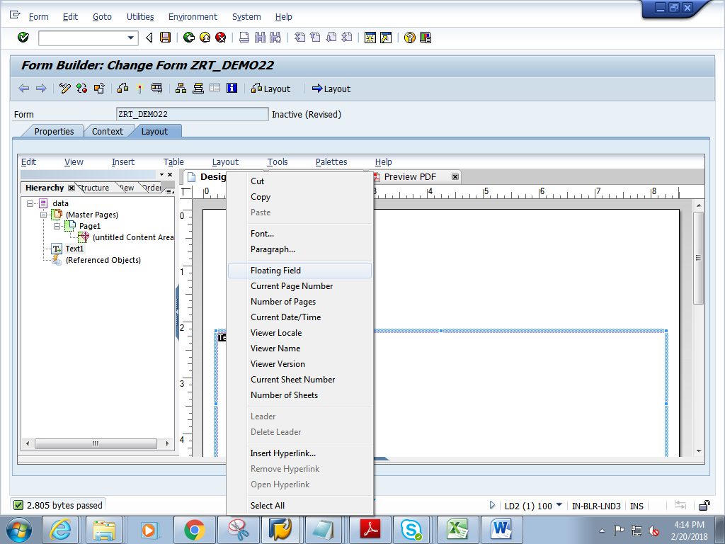

1. Select the word text in the design view, then in the object window->Binding tab-> choose LV_TEXT

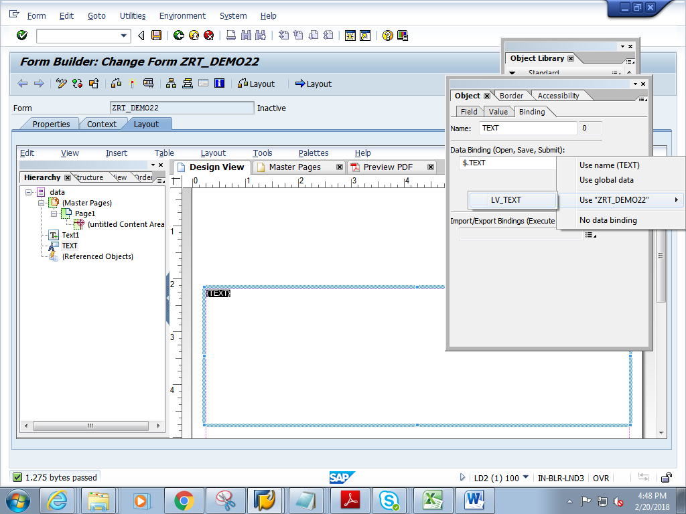

1. Save and close Layout.
2. Click on context. Save and activate the form
3. Execute the form.
4. Click on Print preview

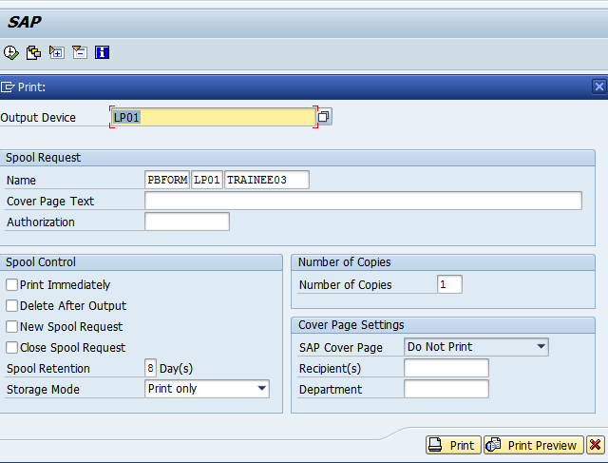

1. Expected output is as follows.

